ASSESSMENT TOOL 2 Name:Jitesh A P
Reg No:192511163
CONCEPT MAPPING

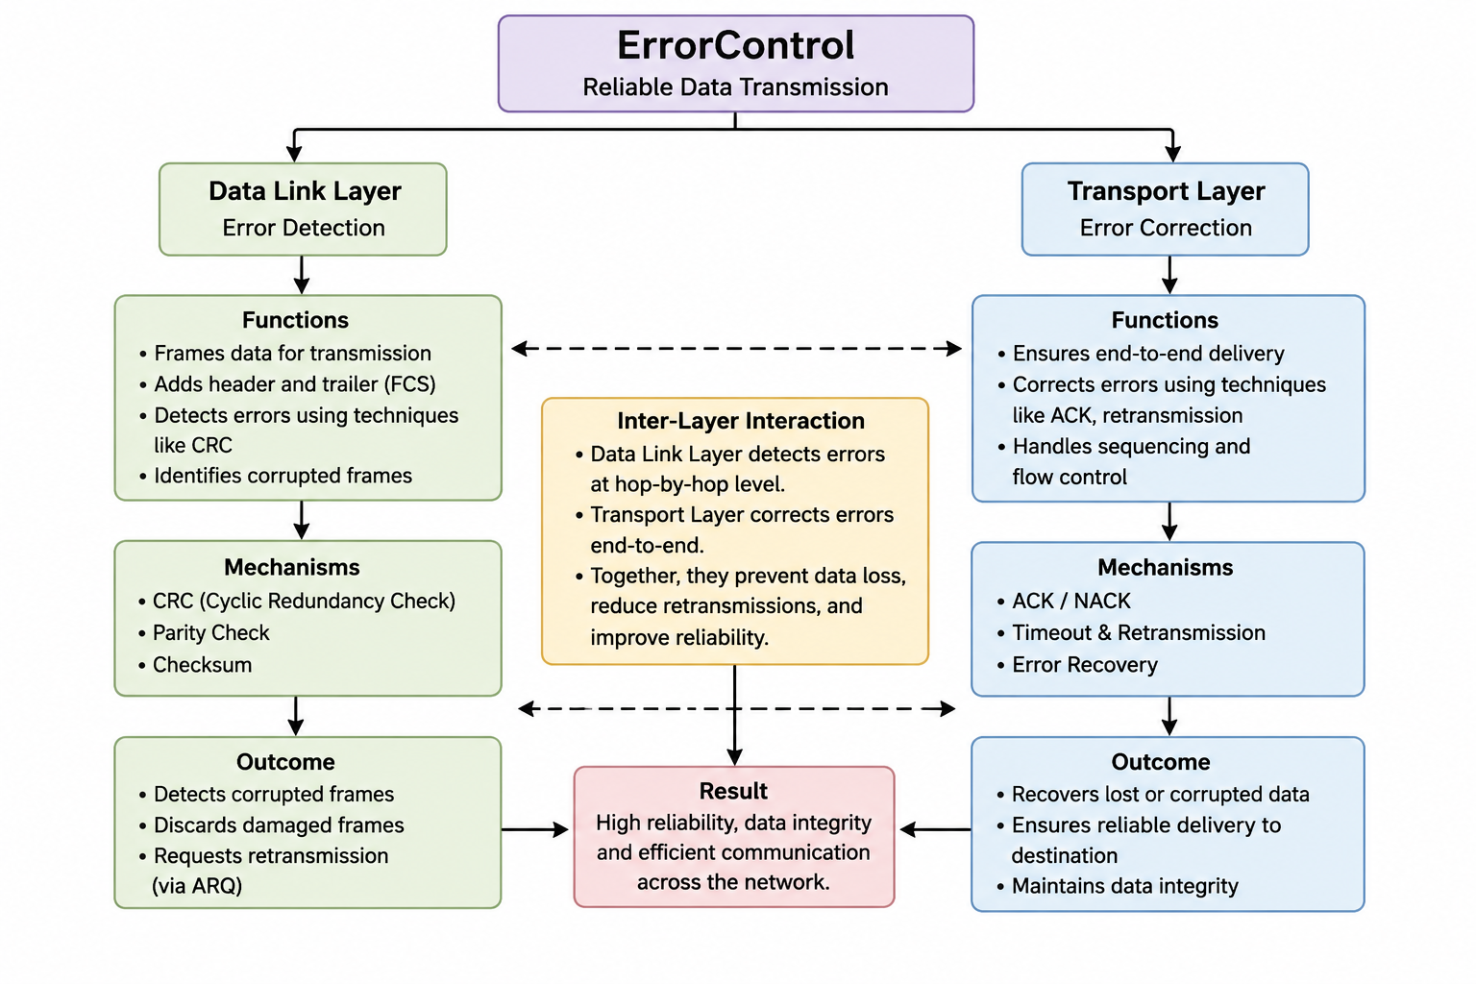

The concept map explains how Error Control improves reliable data transmission by combining the functions of the Data Link Layer and the Transport Layer. The Data Link Layer performs error detection using techniques such as CRC, parity check, and checksum to identify corrupted frames during transmission. When errors are detected, damaged frames are retransmitted. The Transport Layer provides error correction through acknowledgments (ACK), sequencing, flow control, and retransmission mechanisms to ensure end-to-end delivery. Together, these layers reduce data loss, maintain data integrity, improve communication reliability, and ensure that information reaches the destination accurately and efficiently across the network.
• Error control is essential for accurate and reliable communication.
• The Data Link Layer detects errors between two directly connected devices (hop-to-hop communication).
• It uses CRC (Cyclic Redundancy Check), Parity Check, and Checksum to identify corrupted frames.
• If an error is detected, the frame is discarded or retransmitted using ARQ (Automatic Repeat Request).
• The Transport Layer provides end-to-end reliability between the sender and receiver.
• It uses ACK (Acknowledgment), NACK, Timeout, and Retransmission to recover lost or damaged data.
• The Transport Layer also performs flow control and sequence numbering to maintain the correct order of data.
• The interaction of both layers reduces packet loss and transmission errors.
• It improves data integrity, network efficiency, and overall communication performance.
• Together, these layers ensure that data reaches the destination correctly, completely, and without corruption.

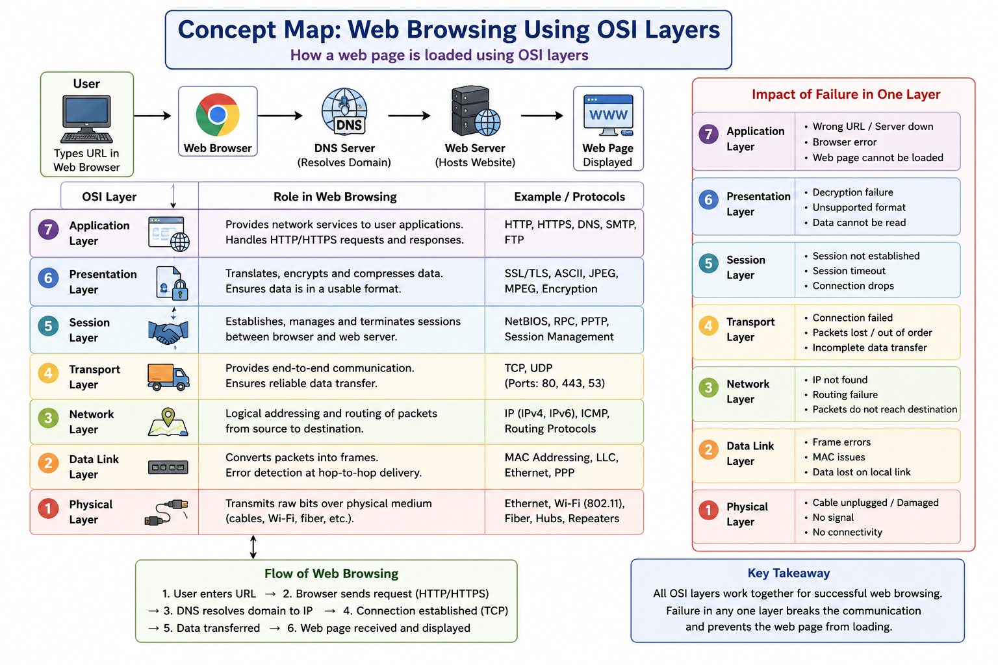

A concept map for web browsing using the OSI model shows how data passes through all seven layers. The Application Layer handles HTTP/HTTPS requests, the Presentation Layer encrypts and formats data, and the Session Layer establishes and manages communication. The Transport Layer ensures reliable delivery using TCP, while the Network Layer routes packets using IP. The Data Link Layer transfers frames between devices, and the Physical Layer sends data as electrical or optical signals. If any layer fails, communication is disrupted. For example, a Network Layer failure prevents packet routing, making the website inaccessible even if the other layers work correctly.

• The OSI model divides communication into seven layers, each with a specific function.

• Application Layer provides services to users such as web browsing, email, and file transfer.
• Presentation Layer performs data encryption, decryption, compression, and formatting.
• Session Layer establishes, maintains, and terminates communication sessions.
• Transport Layer ensures reliable data transfer using TCP, acknowledgments, and flow control.
• Network Layer uses IP addresses to determine the best path for data packets.
• Data Link Layer creates frames, detects transmission errors, and controls access to the network.
• Physical Layer transmits bits through cables, fiber optics, or wireless signals.
• Data is encapsulated as it moves from the Application Layer to the Physical Layer and decapsulated at the receiver.
• If the Network Layer fails, packets cannot reach the destination, causing web pages to fail to load.
• Protocols used in web browsing include HTTP/HTTPS, TCP, IP, Ethernet, and Wi-Fi.
• The OSI model simplifies troubleshooting because each layer can be tested independently.

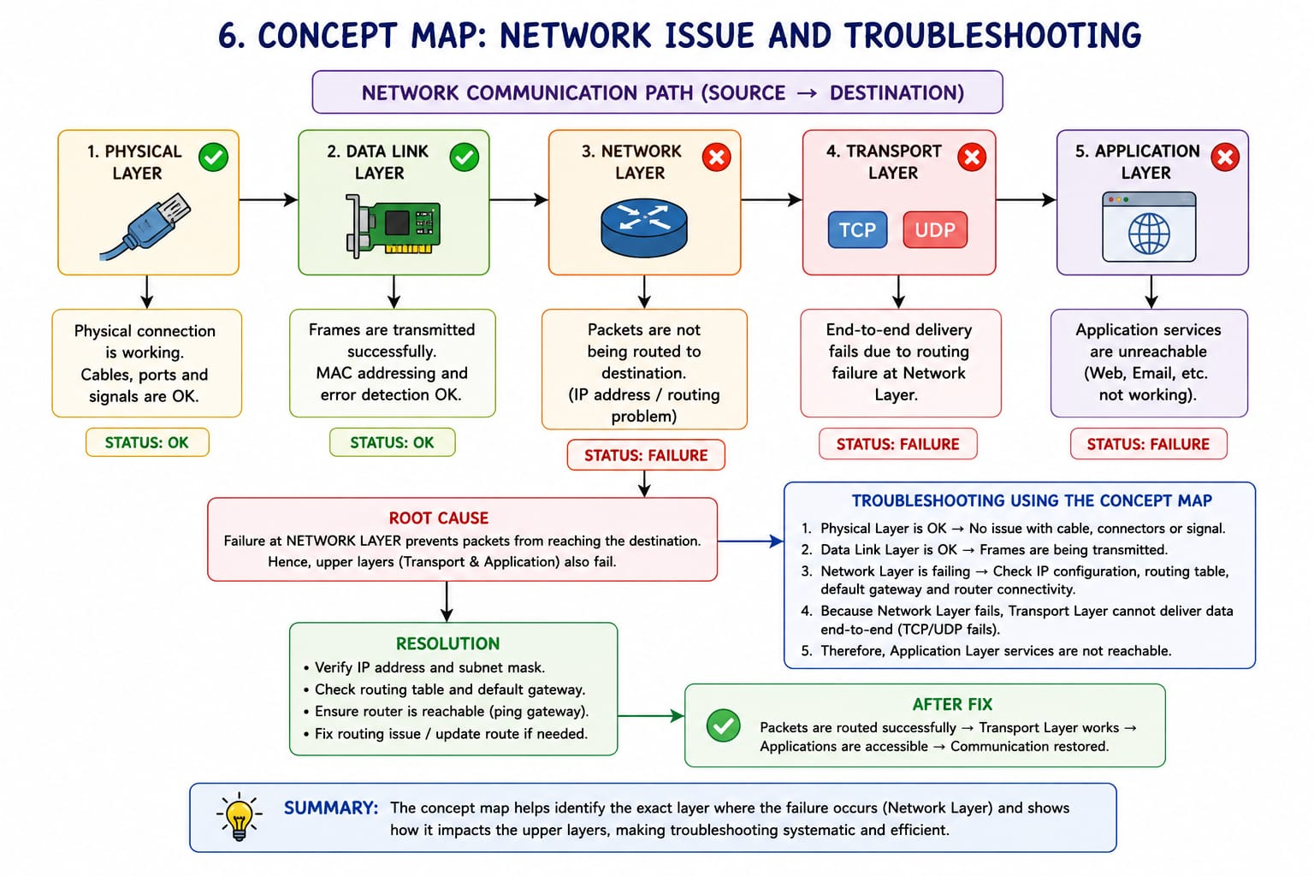

The concept map indicates that the Physical Layer and Data Link Layer are functioning correctly (✔), while the Network Layer, Transport Layer, and Application Layer have failed (✖). This means that the physical connection, such as cables, Wi-Fi, or network devices, is working properly, and data frames are successfully transmitted between directly connected devices. However, the failure at the Network Layer prevents packets from being routed to their destination because IP addressing and routing are not functioning. As a result, the Transport Layer cannot establish reliable communication using TCP or UDP, and the Application Layer cannot provide services such as web browsing, email, or file transfer.
The concept map is useful for troubleshooting because it helps identify the exact layer where communication fails. Since the Physical and Data Link Layers are working, the problem is not related to cables, switches, or local frame transmission. The troubleshooting process should begin by checking the Network Layer, including IP address configuration, subnet mask, default gateway, routing tables, and router connectivity. Once the Network Layer is restored, the Transport Layer and Application Layer can function normally. Thus, the concept map provides a systematic approach to diagnosing network issues, reducing troubleshooting time, improving accuracy, and ensuring efficient restoration of reliable network communication.
• Users may experience websites not loading, failed email delivery, file transfer errors, or inability to access network services.
• Common causes include wrong IP configuration, router failure, routing table errors, firewall restrictions, or network congestion.
• Troubleshooting should follow a bottom-up approach, starting from the Physical Layer and moving upward.
• Network tools such as ping, ipconfig/ifconfig, traceroute/tracert, netstat, and nslookup help identify the exact problem.
• Verifying IP address, subnet mask, default gateway, and DNS settings can quickly locate configuration errors.
• Restarting network devices and checking router status can resolve many Network Layer problems.
• Once the Network Layer is restored, the Transport and Application Layers resume normal operation automatically.

